<$ScrKeepWithNext><$Scr_Ps::0>Arrowgrams Overview
<!$Scr_Ps::0>
Arrowgrams is a way of constructing software using Parts and Wires. Parts can be Schematics, Code, or Parts.

The idea of Arrowgrams is to mimic Electronics Hardware design. Parts are like ICs (see Figure <$n:figure:IntegratedCircuit>). Schematics are collections of Parts (see Figure <$n:figure:Schematic>). Wires look like lines on a diagram. The Arrowgrams editor is like a CAD system - it allows us to place parts on a Schematic and to wire them up.
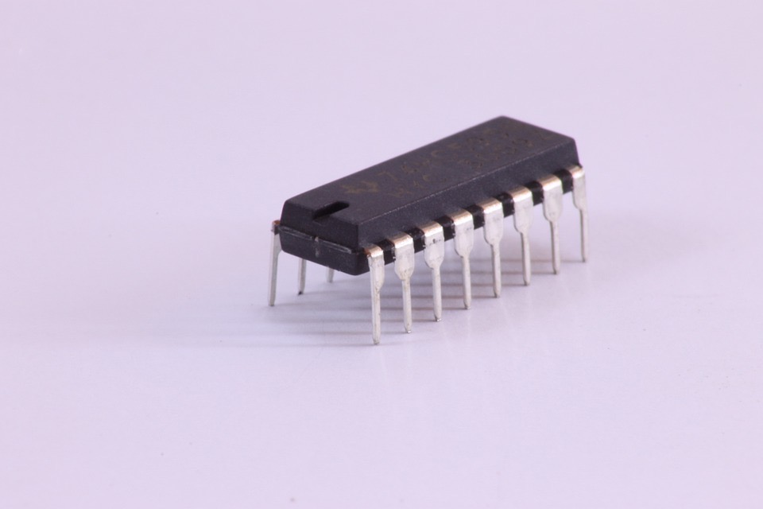
Figure <$n:figure:IntegratedCircuit>

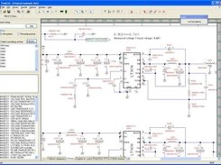
Figure <$n:figure:Schematic>

In Arrowgram, diagrams make intuitive sense. All pedantic issue design decisions are made to allow diagrams to make sense.

A Part consists of 3 items:

- A Kind - the kind determines how the part works, but each Part is a unique instance of a given kind.
- A set of input pins.
- A set of output pins.

Parts communicate with one another via events. Events are messages that can come in bursts, with time in between events.

Parts cannot communicate directly with each other - they can only send events up to their enclosing schematics. The enclosing schematics contain wiring lists that specify what each output pin is connected to. The designer can decide which output pins are wired to which input pins of parts on a schematic. This encapsulates the flow of events within a system. Events can come in “from the outside” if they arrive on an input pin of the schematic. Events can flow out “to the outside” if they are wired/sent to the output pin(s) of a schematic.
<$ScrKeepWithNext><$Scr_H::2><$Scr_Ps::1>Pedantic Issues (not required reading)
- <!$Scr_H::2><!$Scr_Ps::1> ◦ Every Part can process exactly one input event at any one time. This includes Schematic parts, hence, a schematic is busy as long as any of it children parts are processing input events.
- Output pins can send an event to a number of input pins on the same wire. The system guarantees that one event on one wire will reach all of its corresponding parts before any other event is delivered in the same schematic. This property is a form of time ordering and guarantees that there are no system-created race conditions.
- Every part has a queue of input events and another queue for output events. Input events are 2-tuples consisting of {pin, data}, where the pin is a valid input pin of the given part. Output events are also 2-tuples {pin, data} where, in contrast to input events, the pin refers to a valid output pin of the part. The dispatcher converts output pins to input pins when delivering events.
- When a Part sends an output event, the event is not delivered to its destination(s) immediately, but is placed on the output queue of the part. The Dispatcher delivers the queued-up output events only after the part has completed processing of a single event.
- Parts must always run to completion. Parts must not employ infinite loops (nor infinite recursion).
- Input pins of a schematic can be directly connected to the output pins of that same schematic.
- The astute reader will notice that our system resembles the ideas of mutual multi-tasking and event loops. These ideas were tried only in operating systems before being discarded. The ideas, though, remain valid for programming-language level systems such as Arrowgrams.

